**Project GUI using swing**

**\*\* Demo screenshots are at the end of the document.**

**Purpose:**

To build a relatively simple GUI for a Calculator Application. The Calculator you are to build will be a simplified functional replica of your Windows calculator.

**Problem Specification**:

In this project you are to build a relatively simple Swing GUI for a Calculator Application. Your GUI must have exactly the same appearance as the screen capture provided. The image is captured with a screen resolution 1366X768 under Windows 10. The screen capture of the GUI with some implementation details is shown below:

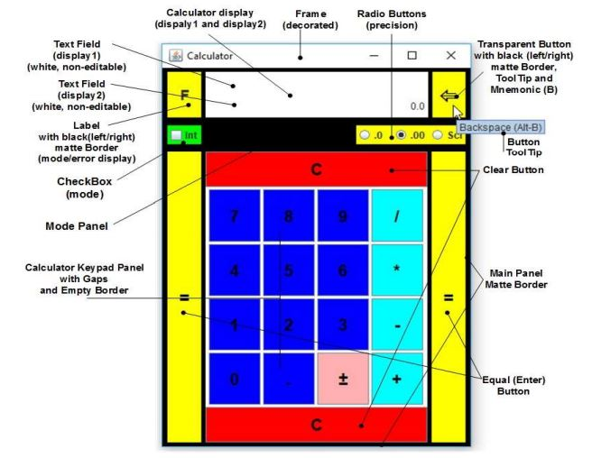

Note: If you are running Windows 7 or 8, the frame borders and decoration may look differently but the rest of GUI should look the same as the one above.

Requirements:

The initial and the minimum size of the application frame must be (380, 520). The initial frame location on the screen must be set by the platform.

The mode/error display label must have a preferred size of (46,55). It must be yellow at launch. It must have a black left/right black matte border with thickness 1/5. And must display the letter F in the middle of the label. Later the background color and the text will change depending on the mode of operation (floating-point or integer) or when an error occurs as a result of some calculation.

The backspace button must have a preferred size of (45,55) and it must yellow. It must be transparent with a black left/right black matte border with thickness 5/1. You must use Unicode (Arrows chart (code page 21XX)) to display the text symbol ⇚ on the face of the backspace button. The button must have a tool tip (see the image above). It must also react to the Alt-B key combination (mnemonic).

All keypad buttons must have a black text. All calculator numeric keypad buttons and the . (dot) button must have a blue background. The calculator arithmetic operator buttons must have a cyan background. The sign(±) button must have a pink background. The Clear buttons (C) must be red in color with a black text (preferred size 0,45); the Equal (Enter) buttons (=) must be magenta in color with a black text (preferred size 46,55). You must use Unicode (Latin 1 supplement code page) to display the plus-minus sign symbol ±.

The calculator display consists of two text fields – display1 and dispaly2. Both text fields must have 16 columns and height of 30. Both text fields must have a white background and must be non-editable. The displayed text must be right aligned. The display2 text field must display 0.0 when the GUI is made visible for the first time. The panel containing the calculator display, the mode/error label, and the backspace button must have a yellow background.

The mode panel consist of a check box (mode) and three floating-point precision radio buttons. They checkbox and the radio buttons must be included in a button group. The radio buttons mast be yellow. The .00 radio button must be selected by default at launch. The checkbox must be green. The panel containing the box container with the radio buttons group and the check box must be black. The radio buttons must be equal in size. The preffered size of the checkbox is (40,0). The mode panel has an empty border.

There must be a gap between the calculator keypad buttons. The calculator keypad panel must be surrounded by an empty border and it must be white.

To arrange the GUI components of the Calculator GUI you should use the following basic layout managers: BorderLayout, FlowLayout, GridLayout.

When the application frame is resized your GUI must have exactly the same behavior (appearance) as the screen capture at the end of the document

The GUI may look a little bit different on your screens because you may have different operating system, screen resolution or different default “Look and Feel”, but relative locations, proportionality and colors must same as on the screen captures.

**Tasks:**

The Object-Oriented analysis of the problem shows that, to solve the problem as stated in the problem specifications, you must design and implement several Java classes as outlined below. All clasess must be placed in a package called calculator.

**Class CalculatorViewController**

The class CalculatorViewController is responsible for building and operating the calculator GUI. It must extend JPanel (not JFrame). The GUI must be build inside a constructor with no-parameters (the default constructor). The CalculatorViewController panel must be surrounded by a black matte border with the following insets (5, 5, 5, 5)

In this implementation the class must contain the following fields only:

private JTextField display1; // the calculator display1 field reference

private JTextField display2; // the calculator display2 field reference

private JLabel error; // the mode/error display label reference

private JButton dotButton; the decimal point (dot) button reference

If you like you can add some final fields to define constants like sizes, text, and colors used in the GUI.

The class must contain the following private method:

private JButton createButton (String text, String ac, Color fg, Color bg, ActionListener handler)

The method is responsible for the creation of group of related buttons with the same basic properties (for example, the calculator numeric keypad buttons). The first parameter text is the button text label (for example, 8 or +). The second parameter ac represents the action command string for that button. The third parameter fg is the foreground color of the button. The fourth parameter bg is the background color of the button. The fifth parameter handler is a reference to instance of the event handler class (for example, object of type Controller). The method performs the following actions:

* Creates a new button with a specified text label;

• Sets the background and foreground colors of the button;

• Set the action command for the button. If ac parameter is null, the action command property of the button need not to be set;

• Set the size of the button font to 20. Do not change the default font name and style.

• Registers the handler as an Action event listener for the button;

• Returns a reference to the created button.

**Note:** If the text of some of the created buttons displays as …, Mac OS users may need to surround each button with an empty border and may need to set a button preferred size.

When creating the calculator keypad you must call this method in a loop in order to create all of the numeric and arithmetic operation buttons and add them to the calculator keypad panel. If the created button is the decimal point (∙) button you must assign the reference returned by the method to the dotButton field before adding it to the panel.

You can use the same method to create other buttons (=, C), but not for the backspace button.

**Class Controller**

In this implementation this class is responsible for handling all the events generated by the GUI. The class must implement the ActionListener interface. The class must be implemented as a private inner class of the CalculatorViewController class. In this implementation, the actionPerformed() method should implement the following only: if the check box or any button (including the radio buttons and the backspace button) is clicked the code of the method must get the action command string from the event and display it on the calculator display text field display2.

**Class CalculatorSplashScreen**

This class is responsible for displaying a splash screen before the launch of the application. The splash screen must display an image, and must contain your name and student number at the bottom of the screen. The class must implement a method called showSplashWindow() that is responsible for building the splash screen and making it visible. It must contain a constructor which has as a parameter the duration time of the splash screen.

